**Mohammad Shoab – 20BCY10054**

**Aadil Haidar Ali – 20BCY10070**

**Om Sahare – 20BCY10091**

**Sanskar Kumar Burman – 20BCY10097**

**Web Application Penetration Testing**

1. **Introduction**

Purpose of the Report: The purpose of this report is to present the findings of the foot-printing and reconnaissance activities conducted on the domain "cvent.com". The assessment aimed to gather information about the target domain's infrastructure, identify potential vulnerabilities, and provide recommendations for improving its security posture.

1. **Foot-printing or Reconnaissance**

**Reconnaissance** refers to the preliminary stage of an attack or penetration testing where an individual or a group gathers information about a target system or network. The goal of reconnaissance is to gather intelligence and gain an understanding of the target's infrastructure, vulnerabilities, and potential entry points. This phase typically involves passive information gathering techniques such as open-source intelligence (OSINT) gathering, network scanning, and enumeration.

**Foot-printing**, on the other hand, is a specific method within the reconnaissance phase. It involves actively collecting information about a target organization, its systems, and its employees to create a "footprint" or profile of the target. Footprinting techniques can include searching public records, social engineering, gathering information from websites, DNS queries, and other similar methods. The collected data is used to identify potential weaknesses or entry points that could be exploited in subsequent stages of an attack.

**In summary**, reconnaissance is the broader process of gathering information about a target, while foot-printing is a specific technique used within reconnaissance to collect detailed information about the target organization and its systems.

**Passive Footprinting or Reconnaissance:**

During the passive foot-printing phase, publicly available information was collected through search engines, social media, and public records. The following information was obtained:

* Screenshot 1: cvent.com homepage, showing the layout and available information.
* Screenshot 2: Contact details found on the website, including the organization's address and phone number.
* Screenshot 3.1 & 3.2: Examining publicly shared content on social media platforms like Facebook, Twitter, LinkedIn, and Instagram to gather information about individuals, organizations, or events.
* Screenshot 4: WHOIS lookup results, revealing the domain registration details, such as the registrar and expiration date.
* Screenshot 5: (Dorking) Using advanced search operators and specific search queries on search engines like Google to identify information that is not typically indexed or easily accessible through regular searches.



Screenshot 1

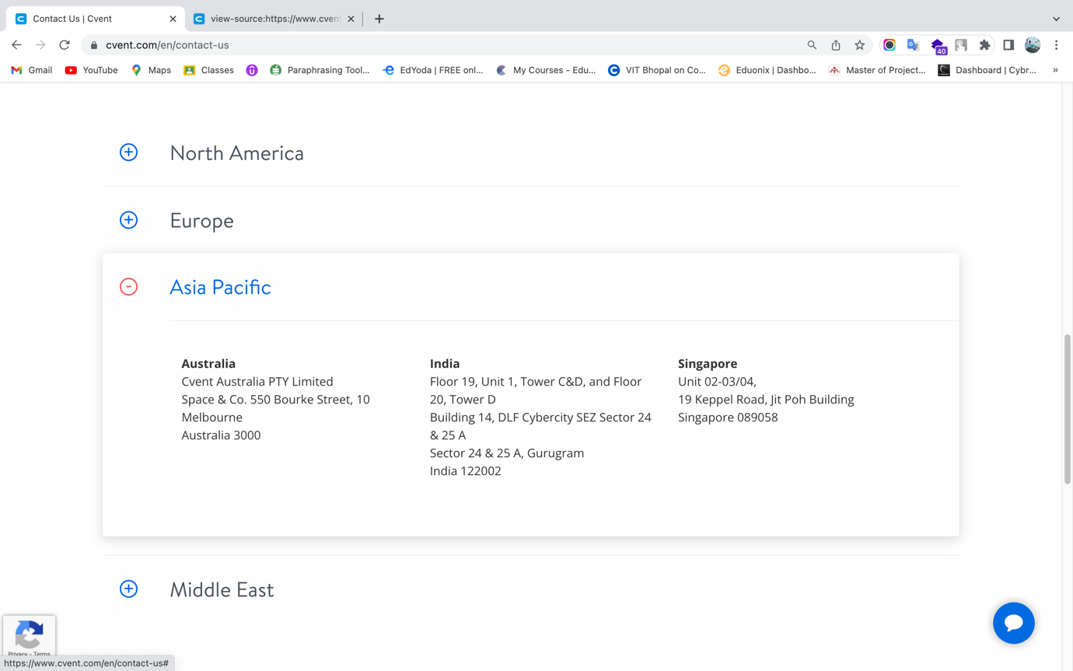

Screenshot 2



Screenshot 3.1

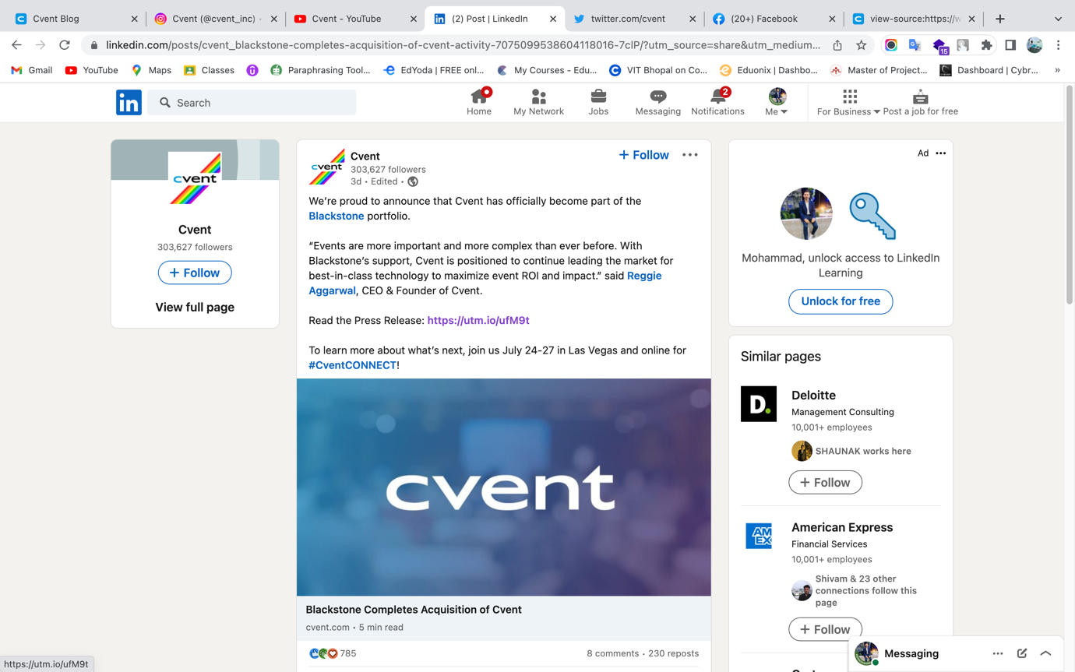

Screenshot 3.2

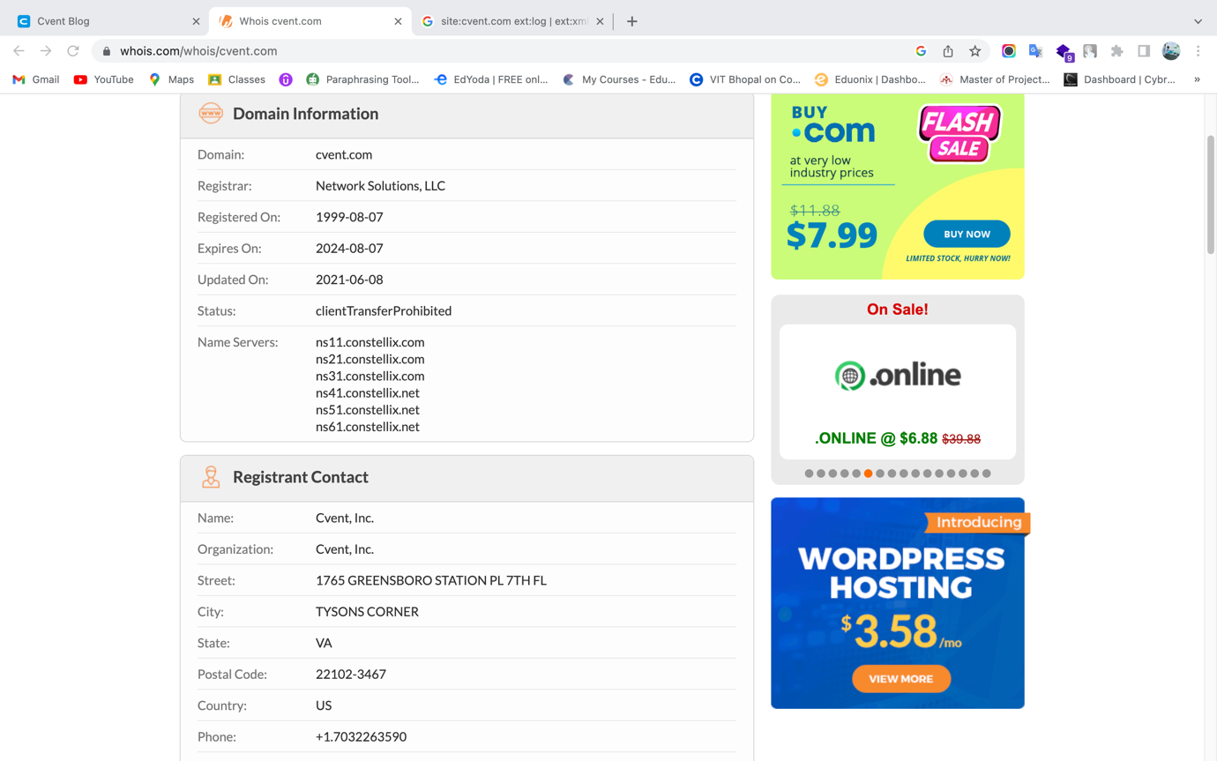

Screenshot 4

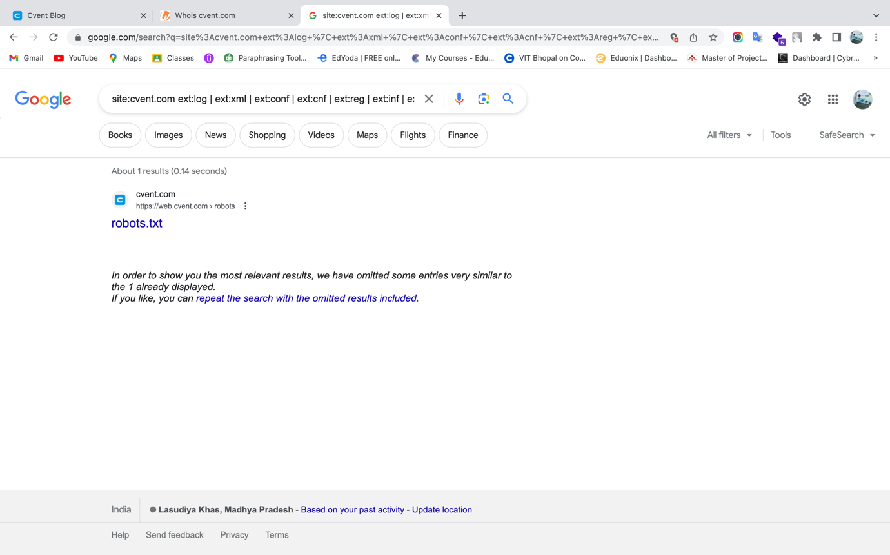

Screenshot 5

**Active Footprinting or Reconnaissance:**

Active techniques were employed to gather additional information about the domain. The following findings were obtained:

* Screenshot 6: Nmap scan results showing open ports on cvent.com's IP address (54.164.188.202).
* Screenshot 7: (Subfinder) Subdomain enumeration to find out all subdomains of the target.
* Screenshot 8: (httpx) Filtering out live subdomains out of all subdomains.
* Screenshot 9.1 & 9.2: (Scretfinder) Discover sensitive data like apikeys, accesstoken, authorizations, jwt, …, etc in JavaScript files.
* Screenshot 9: (dirb) Enumerate directories and files on the target domain, aiming to discover hidden or sensitive information that may not be readily accessible through regular browsing.

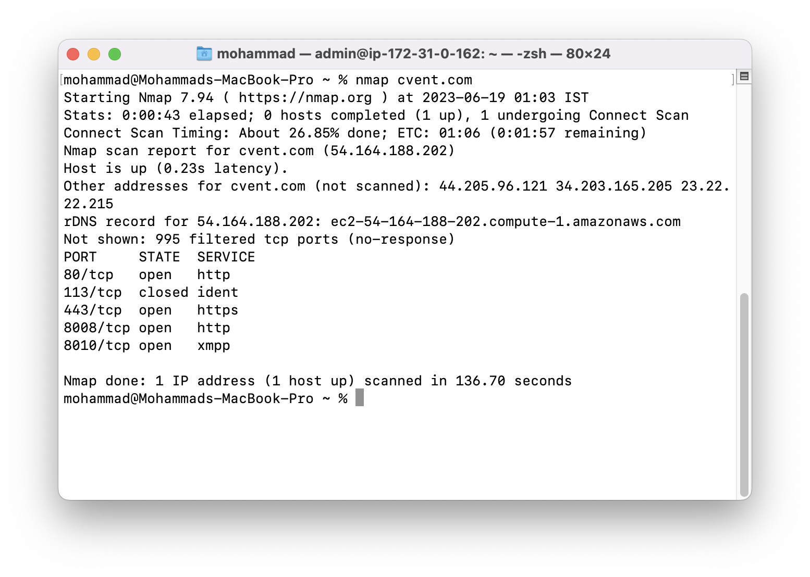

Screenshot 6

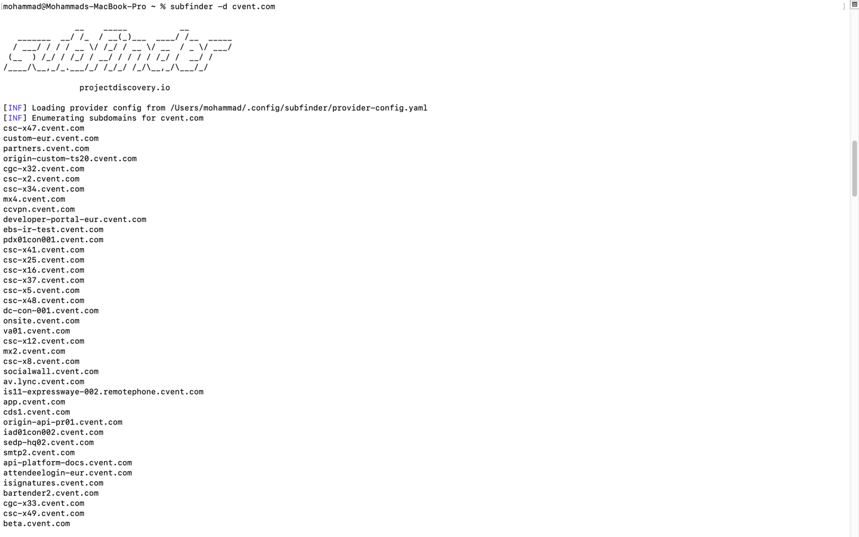

Screenshot 7

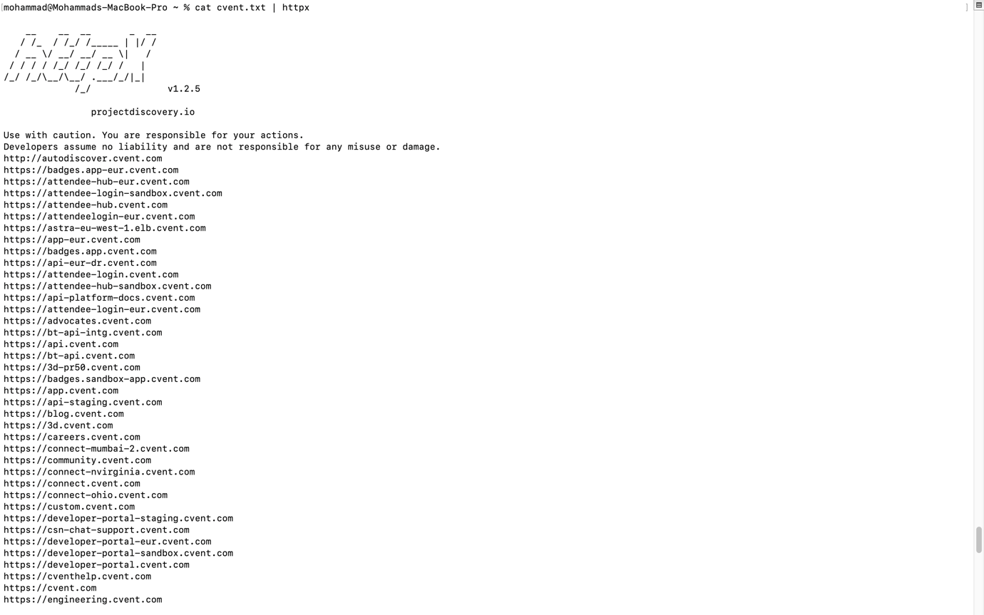

Screenshot 8



Screenshot 9.1

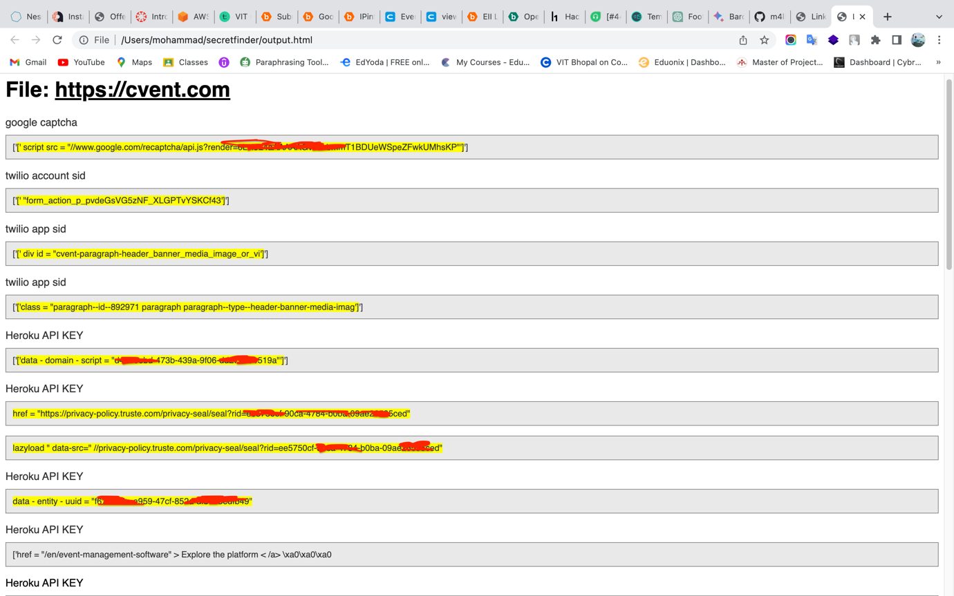

Screenshot 9.2

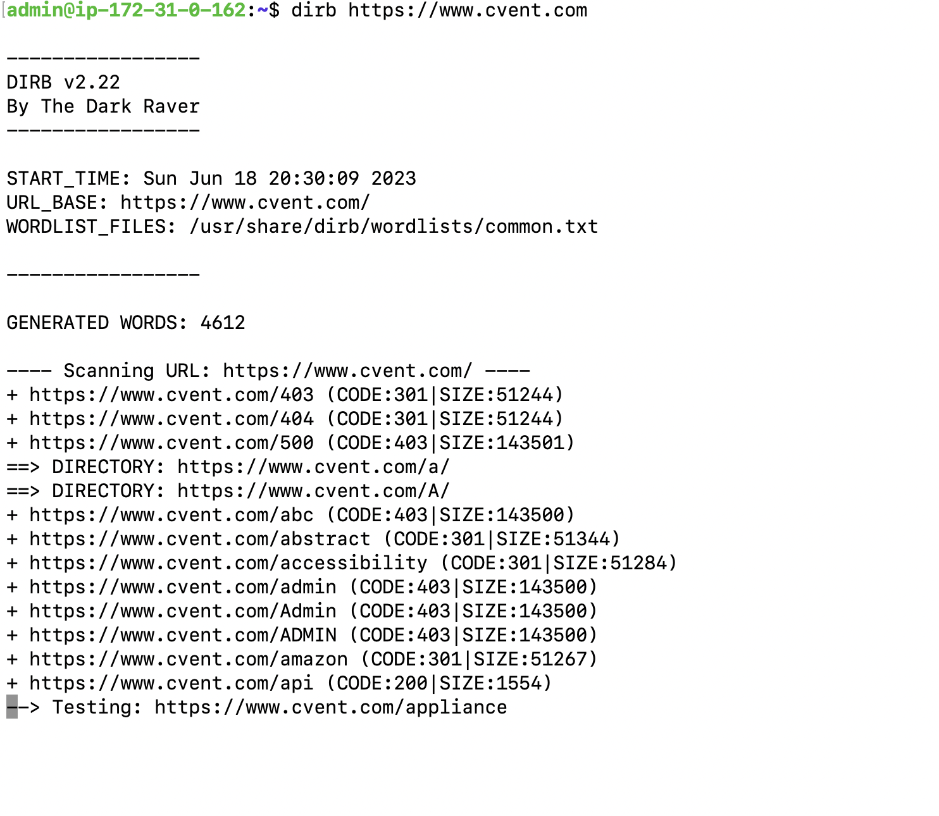

Screenshot 10

1. **Identifying and Exploiting Vulnerabilities present on Open Ports**

We have used **Nmap** to find open ports of our target web server.  
**Command Used to find open ports are:**

1. Check for common open ports.
   * **nmap <ip or domain>**
2. Check for all open ports.
   * **nmap -p- <ip or domain>**
3. Check for specific port.
   * **nmap -p <port_number> <ip or host>**

As we can see in Screenshot 6, I have run basic port scanning for common open ports.

Nmap found total 5 port which our target is using. Out of that four ports, one port i.e., port 113[ident] is closed and remaining 4 ports – 80[http], 443[https], 8008[http] and 8010[xmpp] is open.

As we know https and https is used for communication over a computer network. Whereas XMPP (Extensible Messaging and Presence Protocol) is an open XML technology for real-time communication.

**Nmap can be used for finding known vulnerabilities on open ports.**

So let’s try to check for vulnerabilities on our target system’s ports.

**Command for checking vulnerabilities on any ports is:**

* **nmap -p <port_number> --script=vuln <ip or host>**

I have used Nmap for finding any vulnerabilities present in the open ports as show in Screenshot 10.1, 10.2, 10.3 and 10.4. As we can see, host is not vulnerable which means that Nmap has not found any vulnerability on that port.

In case, if Nmap will found any vulnerability then, we will do some research for finding exploit of that vulnerability and test it to verify that identified vulnerability is true or false-positive.

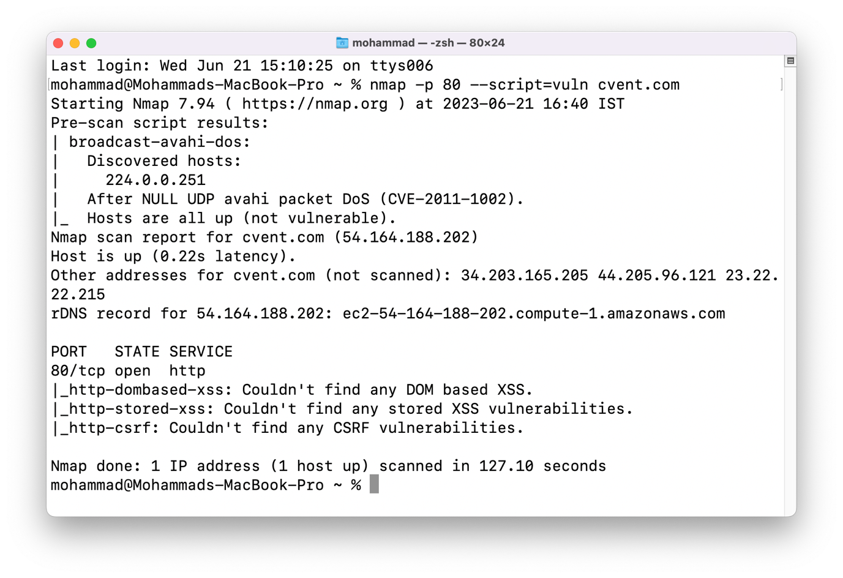

Screenshot 10.1

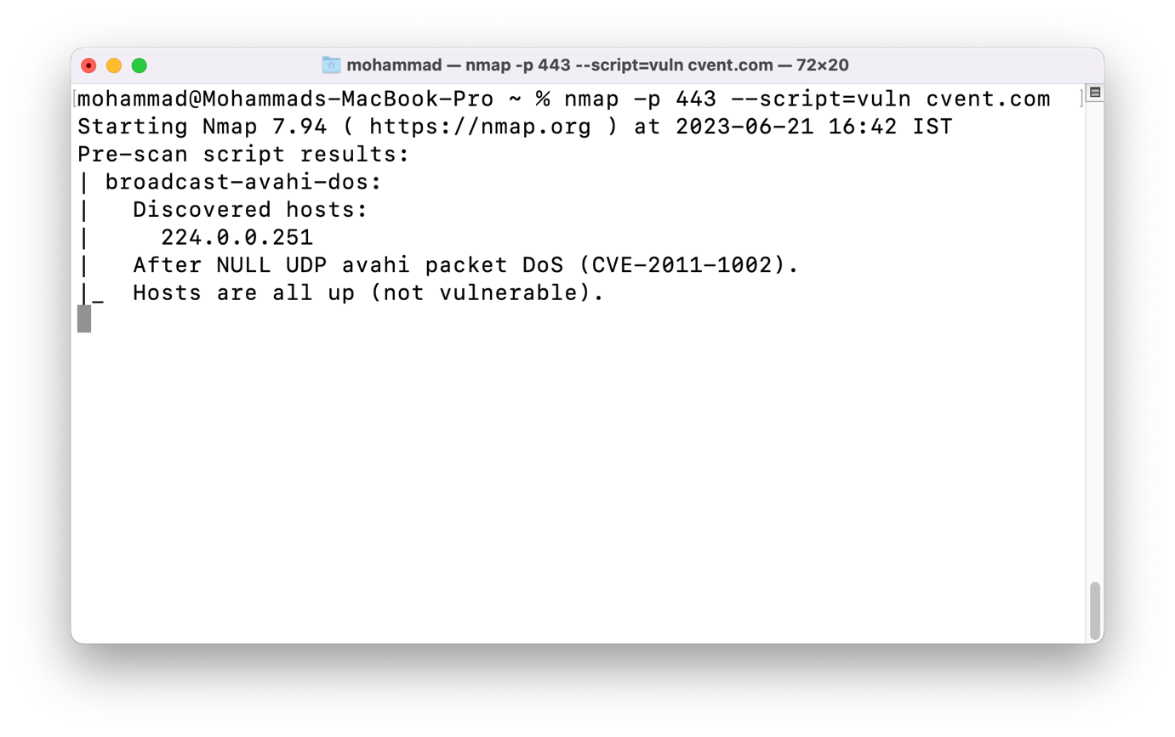

Screenshot 10.2

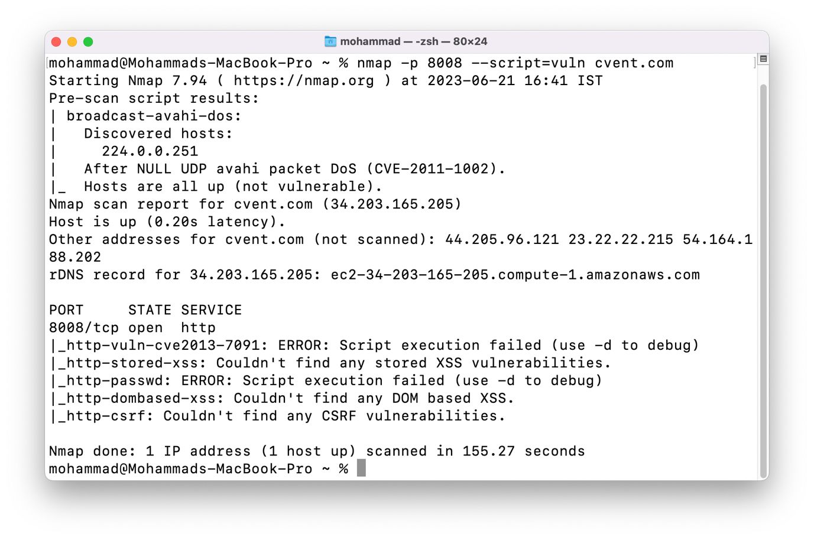

Screenshot 10.3

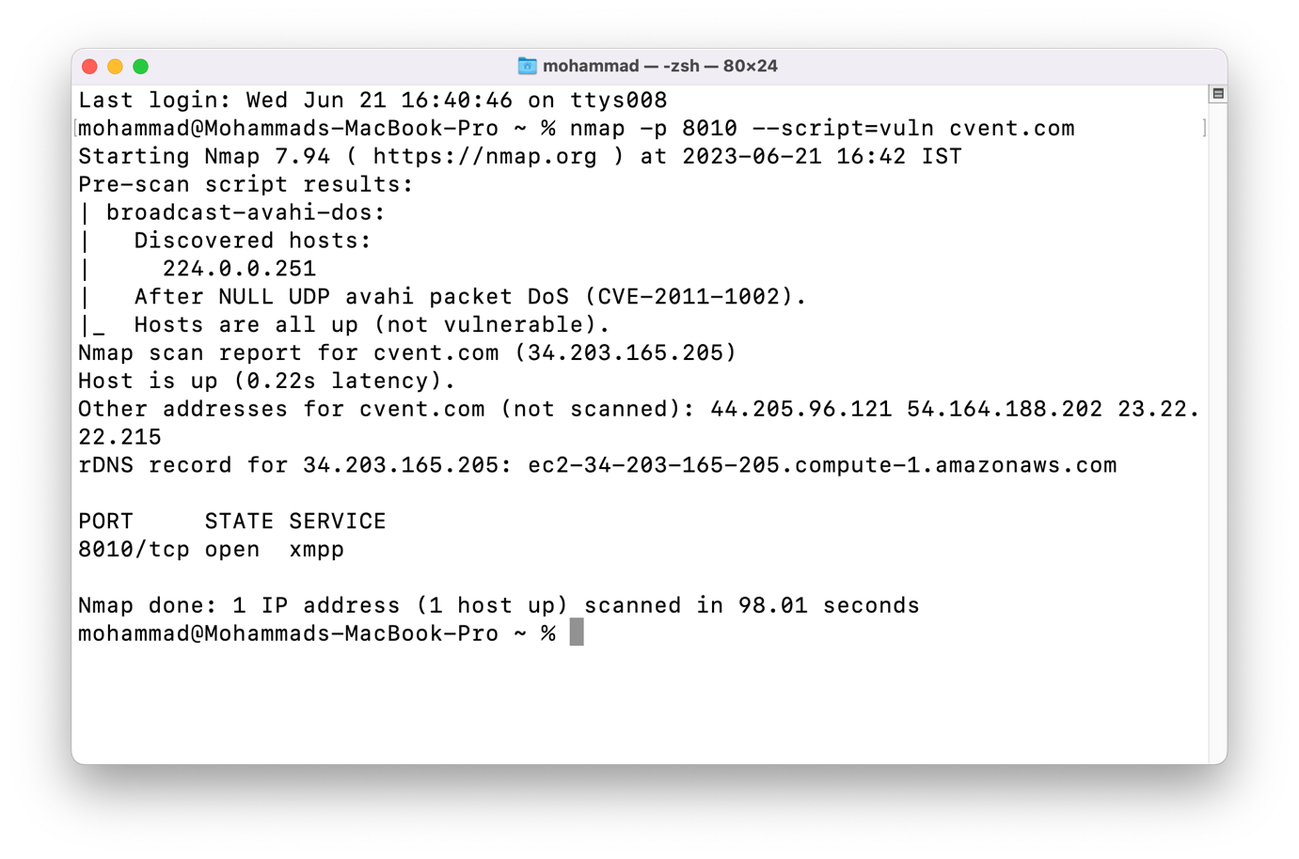

Screenshot 10.4

Now other than http and https, XMPP is only open port.  
So let’s search and find some exploit:

I have found an XMPP vulnerability. i.e., Perform brute force password auditing against XMPP (Jabber) instant messaging servers.

References: <https://nmap.org/nsedoc/scripts/xmpp-brute.html>  
Command to exploit this vulnerability is:

* **nmap -p <port> --script xmpp-brute <ip or host>**

I have tried to exploit this vulnerability but it’s not vulnerable. So attack is not performed as shown in Screenshot 11.

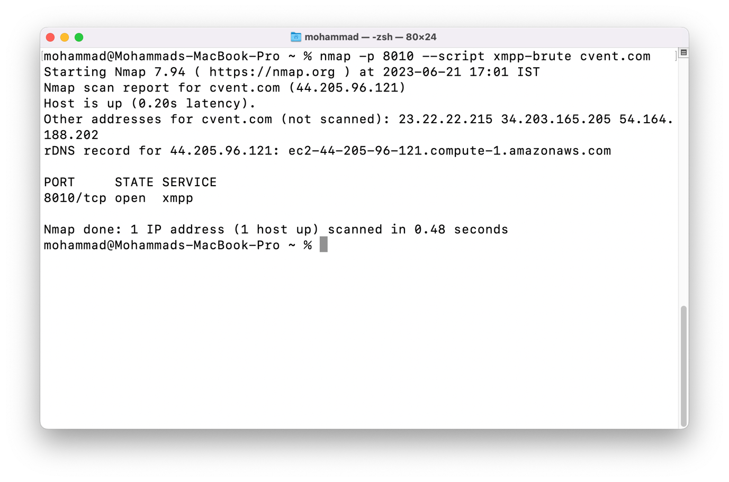

Screenshot 11